In-Place Reversal of a Linked List

1) Definition
A technique to reverse a linked list by rearranging node pointers directly, without using extra memory such as arrays or stacks.
Core idea:
Iteratively change each node’s next pointer so it points to the previous node instead of the next one.

2) Use Cases / Advantages
- Time Complexity: O(n)
- Space Complexity: O(1) (in-place, no extra data structures)
- Fundamental operation for many linked list problems
- Avoids copying data into other structures

3) Benefits
- Minimal memory usage
- Very fast and efficient
- Foundation for advanced linked list algorithms
- Improves pointer manipulation skills
- Clean, iterative logic

4) Recognition Patterns (When to Apply)
Use in-place reversal when the problem involves:
- Modifying node pointers
- Reversing traversal direction
- Working on a contiguous portion of a list
- No requirement for extra arrays or copies
- Palindrome checks on linked lists
- Rotations or reordering of nodes
- Swapping nodes or reversing segments
Common keywords in problems:
reverse, reorder, rotate, k-group, sublist, swap nodes

5) Related LeetCode Problems (Easy → Hard)
Easy / Medium Foundation
- 206 — Reverse Linked List
- 92 — Reverse Linked List II (sublist)
- 61 — Rotate List
- 234 — Palindrome Linked List
Medium
- 143 — Reorder List
- 147 — Insertion Sort List
- 148 — Sort List
- 430 — Flatten Multilevel Doubly Linked List
Hard / Advanced
- 25 — Reverse Nodes in k-Group
- 82 — Remove Duplicates from Sorted List II
- 83 — Remove Duplicates from Sorted List
- 707 — Design Linked List

6) Standard Algorithm (Full List Reversal)
Initialization
prev = null
curr = head
Iteration
Repeat while curr != null:
- Save next node
next = curr.next
- Reverse pointer
curr.next = prev
- Move pointers forward
prev = curr
curr = next
Final Step
return prev // new head of reversed list

7) For Sublist or k-Group Reversal
Additional steps:
- Locate segment boundaries first
- Reverse only nodes within that segment
- Carefully reconnect:
  - Node before segment → new segment head
  - Old segment head → node after segment

In-Place Reversal of a Singly Linked List (Visual)

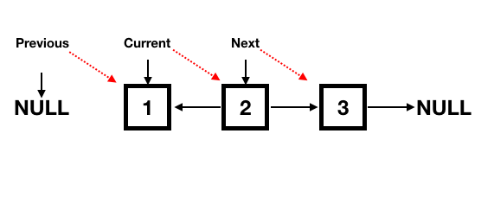
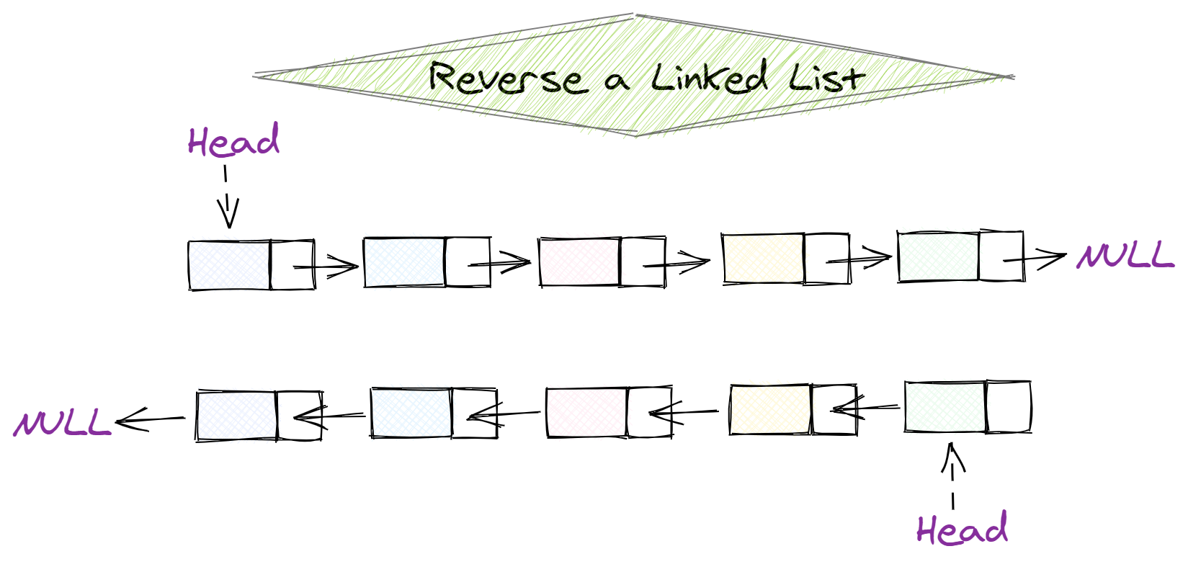

Initial State
head
↓
1 → 2 → 3 → 4 → 5 → null
prev = null
curr = 1

Step 1 — Reverse first node
Save next, flip pointer, move forward
next = 2
curr.next = prev
prev curr
↓ ↓
1 → null 2 → 3 → 4 → 5 → null

Step 2 — Reverse second node
next = 3
curr.next = prev
prev curr
↓ ↓
2 → 1 → null 3 → 4 → 5 → null

Step 3 — Reverse third node
prev curr
↓ ↓
3 → 2 → 1 → null 4 → 5 → null

Step 4 — Reverse fourth node
prev curr
↓ ↓
4 → 3 → 2 → 1 → null 5 → null

Step 5 — Reverse last node
prev
↓
5 → 4 → 3 → 2 → 1 → null
curr = null → stop

Final Result
New head = prev
5 → 4 → 3 → 2 → 1 → null

Key Pointer Movement Rule
At every iteration:
next = curr. next
curr. next = prev
prev = curr
curr = next

